# Step 1: Install dependencies

!pip install scikit-learn pandas

# Step 2: Import libraries

import pandas as pd

from sklearn.model_selection import train_test_split

from sklearn.ensemble import RandomForestClassifier

from sklearn.metrics import accuracy_score

import joblib

from google.colab import files

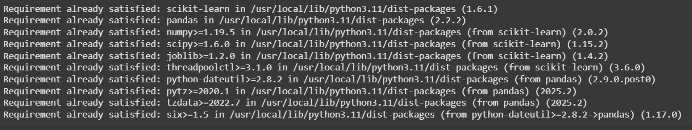

# Step 3: Load dataset and train model

url = 'https://raw.githubusercontent.com/jbrownlee/Datasets/master/pima-indians-diabetes.data.csv'

columns = ['Pregnancies', 'Glucose', 'BloodPressure', 'SkinThickness', 'Insulin',

'BMI', 'DiabetesPedigreeFunction', 'Age', 'Outcome']

df = pd.read_csv(url, names=columns)

X = df.drop('Outcome', axis=1)

y = df['Outcome']

X_train, X_test, y_train, y_test = train_test_split(X, y, test_size=0.2, random_state=42)

model = RandomForestClassifier()

model.fit(X_train, y_train)

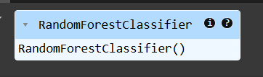

# Step 4: Evaluate model

accuracy = accuracy_score(y_test, model.predict(X_test))

print(f"Model Accuracy: {accuracy * 100:.2f}%")

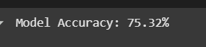

# Step 5: Save model

joblib.dump(model, 'diabetes_model.pkl')



# Step 6: Upload user CSV file

print("\nPlease upload a CSV file with the following columns:\n")

print(columns[:-1]) # Show required columns (excluding 'Outcome')

uploaded = files.upload()

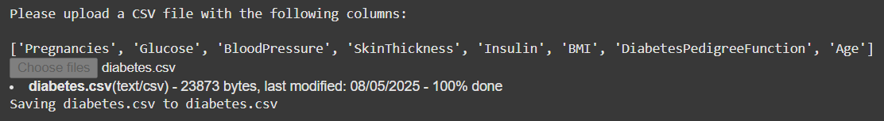

# Step 7: Load uploaded file

for filename in uploaded.keys():

user_df = pd.read_csv(filename)

print(f"\nUploaded Data Preview:\n{user_df.head()}")

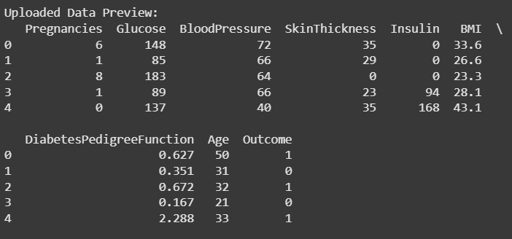

# Step 8: Load model and predict

model = joblib.load('diabetes_model.pkl')

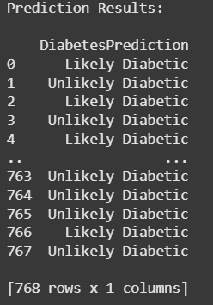

predictions = model.predict(user_df)

# Step 9: Show results

user_df['DiabetesPrediction'] = ['Likely Diabetic' if p == 1 else 'Unlikely Diabetic' for p in predictions]

print("\nPrediction Results:\n")

print(user_df[['DiabetesPrediction']])

# Optional: Download results

user_df.to_csv("prediction_results.csv", index=False)

files.download("prediction_results.csv")

GOOGLE COLAB PROJECT LINK:

<https://colab.research.google.com/drive/10eloduJd2dkZatBdim4xQOxtFdmmrDcR>